April 29, 2008 ML-8G115

Ms. A. Hebert, Chief
Mobile Source Operations Division
Air Resources Board
9480 Telstar Avenue, Suite 4
El Monte, CA 91731

Dear Ms. Hebert:

Subject: General Motors Functional Test Plan for the 2008 Model Year

Please find attached the General Motors Functional Test Plan for the 2008 model year. This is being submitted for approval in accordance with the requirements of the California Assembly-Line Test Procedures. For the 2008model year, the determination of compliance with regard to on-board or off-board testing of OBD II P-codes has been made based on engineering data and/or engineering judgment. Except for the serial data link, which must be present to run our functional test, all applicable emissions systems and components are covered in the attached P-code tables.

The attached document contains, in part, information which constitutes trade secrets, commercial data or confidential, proprietary information which is not normally disclosed to third parties because they could gain an unfair competitive advantage from it. Accordingly, General Motors believes the attached document contains information which constitutes trade secrets and commercial information within the meaning of Section 6254.7 of the California Public Records Act and is entitled to confidential treatment pursuant to the California Public Records Act (Government Code Section 6250 et seq.) and Sections 91000-91022 of Title 17 of the California Code of Regulations. In the event that CARB does not agree with our position regarding confidential treatment of the subject information, we request the opportunity to discuss the matter with you or the CARB General Counsel before any decision is made regarding its release.

If you have any questions concerning this matter, please contact Mr. Antonio M. Martino at
818-997-5517 or Jim York 248-685-5758.

Sincerely,

Randall C. Harvey, Group Manager
Compliance & Certification

RCH/JY
Attachments
c: A. Martino
Functional Test Plan

Emission-Related Components and/or Systems*

The purpose of the functional test plan is to ensure that the emission control system components of California vehicles are assembled correctly and functioning properly.

Dynamic Vehicle Test (DVT)

Emission-related systems controlled by the engine control module (ECM), transmission control module (TCM), powertrain control module (PCM), or vehicle control module (VCM), as applicable, are functionally tested by the dynamic vehicle test (DVT). The DVT is conducted with the vehicle on a roll test machine. There are multiple DVT test sites at each vehicle assembly plant. Each DVT test site has a test computer. Each vehicle's ECM/TCM/PCM/VCM incorporates a feature which monitors ECM/TCM/PCM/VCM activity and produces data showing the status of all sensors and controls that are monitored. The data are fed to the external test computer by means of the vehicle's data link connector (DLC, also known as ALDL) to the test computer. The test computer prompts the test operator by means of a display unit through all required test modes. Test algorithms and parameters which control running conditions within specified ranges are stored in the test system. When monitored sensor or control outputs in the data do not correspond to predetermined response parameters, a fault is indicated.

Successful communication of data to the DVT verifies that the on-board diagnostic system and serial communication link is functioning. The DVT interrogates the vehicle's ECM/TCM/PCM/VCM for diagnostic trouble codes. Any diagnostic trouble codes identified during the DVT by the on-board diagnostic (OBD) system, and any "malfunctions" or "faults" identified by the off-board DVT checks, are recorded. All vehicles must pass DVT prior to shipment. A description of the functional test process is shown in Figure 1. The DVT drive cycle / test sequence is shown in Figure 2.

The following systems, components and functions are verified by an off-board computer during DVT.

Air-Fuel Control/Fuel Injectors
The DVT monitors the oxygen sensor and fuel trim values to verify that the closed loop system is functional and air-fuel ratio is in control. If the exhaust is lean or rich to a level that is outside the determined parameters, the DVT will set a "fault." In this way, significant lean conditions such as vacuum leaks and rich conditions such as high fuel pressure or rich injectors are detected. Likewise, if the fuel trim correction is outside the parameters the DVT will set a fault.

Throttle System (Throttle Position Sensor and Pedal Position Sensor)
Sensor voltages are measured and compared to acceptable parameters and must exhibit a large enough delta during the DVT.
____________________________________________________________________
* Not all components/systems are applicable for all products. Please see certification documentation.
Engine Coolant Temperature Sensor (ECT Sensor)
The DVT verifies that the ECT sensor output is within acceptable parameters and that the engine can reach and maintain a warm engine condition.

Oxygen Sensors
The DVT verifies that the pre-catalyst oxygen sensor(s) are operating and transitioning between rich and lean states. The DVT verifies that the post-catalyst oxygen sensor(s) are operating within acceptable parameters.

Camshaft Position / Sensor and Crankshaft Position Sensor
Camshaft position and/or crankshaft position are measured and compared to acceptable parameters.

Idle Air Control Valve (IAC Valve)
The DVT verifies that the ECM/PCM/VCM can control to the desired idle speed within acceptable parameters.

ECM/TCM/PCM/VCM System
Successful communication with the controllers by the DVT verifies that the controllers are functioning.

Mass Air Flow Sensor (MAF Sensor)
Sensor voltage is measured and compared to acceptable parameters and must exhibit a large enough delta during the DVT.

Manifold Absolute Pressure Sensor (MAP Sensor)
Sensor voltage is measured and compared to acceptable parameters and must exhibit a large enough delta during the DVT.

EGR System Test
The EGR valve is opened and a corresponding change in manifold air pressure (MAP) and/or EGR pintle position sensor feedback must occur.

Intake Air Temperature Sensor (IAT Sensor)
The DVT verifies that the IAT sensor output is within acceptable parameters.

Transmission Fluid Pressure Sensor/Switch Assembly/Range Sensor Switch
The DVT requires the pressure sensing manifold (PSM) to indicate every position.

Transmission Shift Solenoids/Stepper Motors
The DVT verifies that the transmission shifts manually and automatically.
Torque Converter Clutch (TCC) System
The DVT verifies the TCC functionality based on reported feedback from the vehicle controller.

Transmission Temperature Sensor
The DVT verifies that the transmission temperature sensor output is within acceptable parameters.

Transmission System
The DVT verifies that the transmission shifts into all gears by monitoring the transmission gear ratio.

Vehicle Speed Sensor (VSS)
The DVT verifies that the ECM/TCM/PCM/VCM vehicle speed input is within acceptable parameters as compared to the speed of the roll test machine.

Clutch Switch
The DVT verifies that the clutch switch status has changed in response to the operator depressing the clutch.

Brake Switch
The DVT verifies that the brake switch status has changed in response to the operator depressing the brake.

Four Wheel Drive Low Circuit Performance
The DVT verifies switch functionality by comparing switch position to vehicle operation.

Electric Cooling Fan(s)
The fan(s) is turned on and the system voltage is monitored for a corresponding drop.

AIR System
The DVT exercises the AIR system while the oxygen sensor(s) are monitored for an appropriate response.

Engine Operation
The DVT determines normal engine behavior using data from the engine coolant temperature sensor, manifold absolute pressure sensor, idle air control valve, ignition, and mass air flow sensor to determine if they are within acceptable parameters. Based on all of these inputs, a number of functional checks are conducted, including ignition timing, misfire, electronic spark timing, and fuel injectors.

Other Functional Tests

Some emission-related systems operate independently and are not monitored by the DVT. Various stand-alone tests and inspection operations are used to verify integrity of the systems and components. Other emission-related components or systems do not lend themselves to a functional test in the assembly environment. In such cases, functional testing/verification is required of the supplier.

Evaporative Emission/ORVR System
The suppliers of all enhanced evaporative emissions/ORVR system components, using statistically valid sampling, assure all parts are leak free before they ship (vendor qualified). Visual inspection during assembly is performed to identify wrong routings, pinched or loose connections and disconnections of mechanical, vacuum and electrical items.

Catalytic Converter
The content of catalytic converters is assured by the supplier before shipment. The composition of the catalyst material is verified on a lot basis. In the converter assembly process, converters are 100% tested for freedom from leaks.

Emission-Related Hoses, Tubing, Clamps, Belts, Fittings, Wiring, Connectors, Sensors and Switches Interconnecting in emission-related systems is functionally verified by respective functional tests on individual systems. In most cases, disconnects or blocked passages inhibit system function and result in "fault" detection in the functional test. The assembly integrity of clamps, hoses, tubing, and belts is subjective and depends on individual assembly operations. Visual inspection during assembly is performed to identify wrong routings, pinched or loose connections and disconnections of mechanical, vacuum, ignition control and electrical items. Various sensors, switches and connectors are either checked independently, vendor qualified, and/or DVT verified.

Positive Crankcase Ventilation System The function of the PCV valve is assured by the supplier before shipment. Visual inspection of the PCV system is conducted during manufacture. The general integrity of the PCV system, such as gross leaks, would be detected during the DVT process.

Engine Knock Sensor (KS)
Visual inspection during assembly will verify that the knock sensor is properly connected.

Thermostat
Each thermostat is functionally checked by the supplier before shipment.
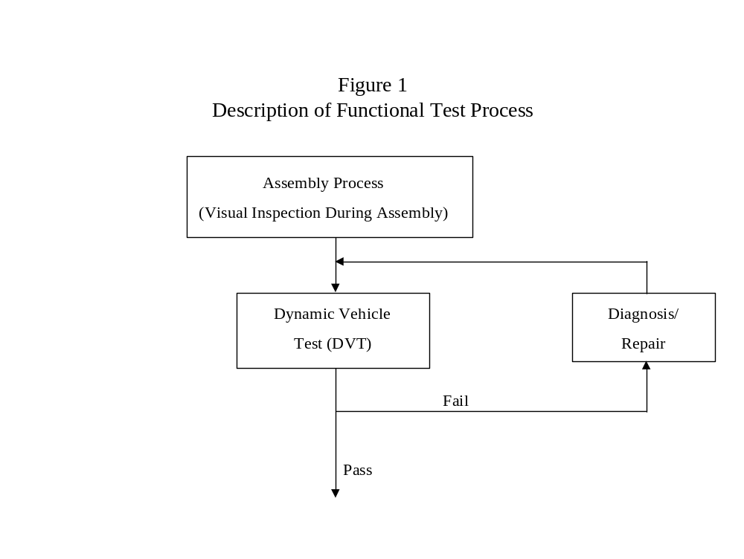
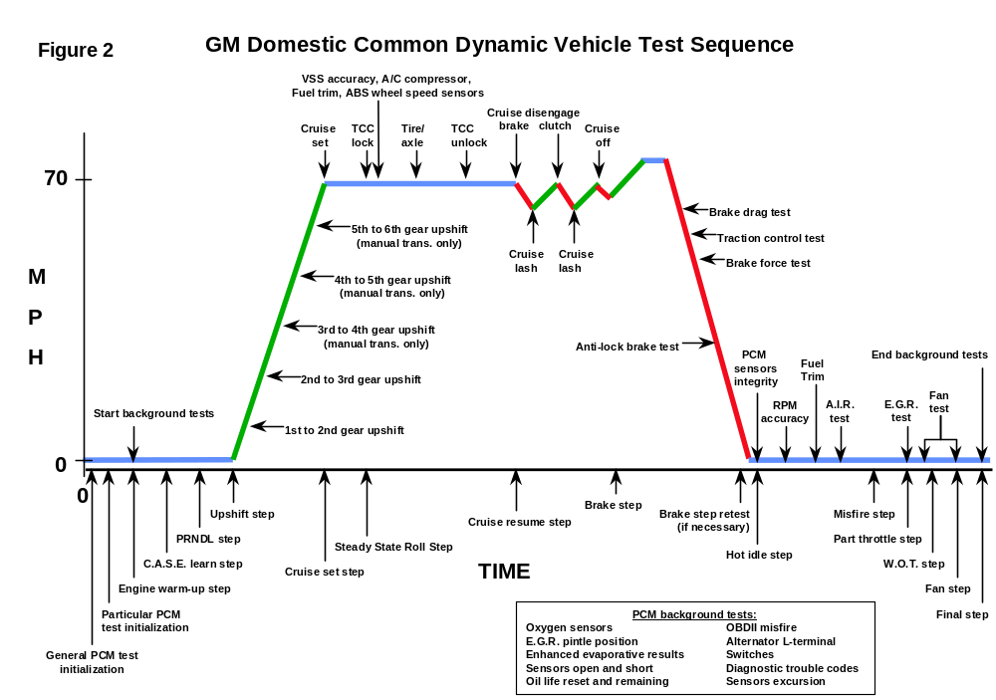

Component/System Monitored | Fault Code(s) | ITP OBD II Checks  Carried Out By |  | Comments
INPUT COMPONENTS |  | OBD II System | Offboard DVT
Mass Air Flow (MAF) Sensor/System | P100, P0101, P0102, P0103, P2281 | A
Manifold Absolute Pressure (MAP) Sensor/System | P023D, P0069, P0106, P0107, P0108, P1106, P1107, P1108, P1128, P1129, P1451, P2227, P2228, P2229 | A
Air Temperature (IAT) Sensor | P0096, P0097, P0098, P0099, P0111, P0112, P0113, P0114, P0640, P1101, P1110, P154A, P154B, P154C, P154D, P2070, P2199 | A
Engine Coolant /Oil Temperature (ECT) Sensor | P0115, P0116, P0117, P0118, P0119, P0125, P0126, P1126, P1258, P0A01, P0A02, P0A03, P0A06, P0A07 | A
Engine Coolant /Oil Temperature (ECT) Sensor | P011A, P0196, P0197, P0198, P050C, P2183, P2184, P2185 | B
Throttle Position (TP) Sensor/System | P0068, P0120, P0121, P0122, P0123, P02E0, P02E7, P02E8, P02E9, P0220, P0221, P0222, P0223, P2107, P2119, P2135, P2172, P2176, P2553, P2554, | A
Oxygen Sensor B1S1 | P0030, P0031, P0032, P0053, P0130, P0131, P0132, P0134, P0135, P2195, P2196, P2231, P2237, P2238, P2239, P2243, P2245, P2251, P2252, P2253, P2297, P2414, P2626, P2627, P2628, P2A00 | A
Oxygen Sensor B1S1 | P0133, P1132, P1133, P1134, P1135, P1136, | B | C, E, F

Component/System Monitored | Fault Code(s) | ITP OBD II Checks  Carried Out By |  | Comments
INPUT COMPONENTS |  | OBD II System | Offboard DVT
Oxygen Sensor B1S2 | P0036, P0037, P0038, P0054, P0137, P0138, P0139, P0140, P0141, P2096, P2097, P2232, P2247, P2249, P2270, P2271, P2629, P2630, P2631, P2A01 | A
Oxygen Sensor B1S2 | P0137, P1137, P1138, P1131, P1141, P1142 | B | C, E, F
Oxygen Sensor B2S1 | P0050, P0051, P0052, P0059, P0150, P0151, P0152, P0153, P0154, P0155, P2240, P2241, P2242 | A
Oxygen Sensor B2S1 | P0153, P1153, P1154, P2197, P2198, P2234, P2254, P2255, P2256, P2298, P2415, P2A03 | B | C, E, F
Oxygen Sensor B2S2 | P0056, P0057, P0058, P0060, P0158, P0159, P0160, P0161, P2098, P2099, P2235, P2272, P2273, P2A04 | A
Oxygen Sensor B2S2 | P0157 | B | C
Electronic Throttle Control System (ETC) | P0638, P1125, P1516, P1523, P1530, P1551, P1791, P1795, P2100, P2101, P2105, P2108, P2111, P2112, P2119, P2120, P2121, P2122, P2123, P2125, P2126, P2127, P2128, P2138, P2776 | A
Knock Sensor (KS)
Knock Sensor (KS) | P0324, P0325, P0326, P0327, P0328 P0330, P0331, P0332, P0333 | B |  | Visual inspection for positive connection.  Supplier functionally checks sensor.
Crankshaft Position (CKP) Sensor | P0016, P0017, P0018, P0315, P0335, P0336, P0337, P0338, P0339, P0385, P2617 | A
Crankshaft Position (CKP) Sensor | P0386, P1344 | B | F

Component/System Monitored |  | Fault Code(s) |  |  | ITP OBD II Checks  Carried Out By |  | Comments
INPUT COMPONENTS |  |  |  |  | OBD II System | Offboard DVT
Camshaft Position (CMP) / Sensor |  | P000A, P000C, P0010, P0011, P0013, P0014, P0016, P0017, P0020, P0021, P0023, P0024, P0340, P0341, P0342, P0343, P0345, P0346, P0347, P0348, P0365, P0366, P0367, P0368, P0369, P0390, P0391, P0392, P0393, P2088, P2088, P2089, P2090, P2091, P2092, P2093, P2094, P2095 |  |  | A
 |  |  |  |  | B | F
Electronic Spark Timing |  | P1300, P1312, P1315, P1340, P1351, P1352, P1353, P1354 |  |  | A
Ignition Control Circuit |  | P0350, P0351, P0352, P0353, P0354, P0355, P0356, P0357, P0358, P0381, P0671, P0672, P0673, P0674, P0675, P0676, P0677, P0678, P2300, P2301, P2303, P2304, P2306, P2307, P2309, 2310 |  |  | A
 |  | P167D |  |  | B
Tank Pressure Sensor |  | P0451, P0452, P0453, P0454 |  |  | A

Component/System Monitored |  | Fault Code(s) |  |  | ITP OBD II Checks  Carried Out By |  | Comments
INPUT COMPONENTS |  |  |  |  | OBD II System | Offboard DVT
Transmission Turbine Input Speed Sensor |  | P0716, P0717, P0718, P0727 |  |  | A
Transmission Vehicle Output Speed Sensor |  | P0500, P0501, P0502, P0503, P0721, P0722, P0723 |  |  | A
Transmission Range Sensor Switch |  | P0705, P0706, P0707, P0708, P1815, P1816, P1818, P1896 |  |  | A
Transmission Temperature Sensor |  | P0712, P0713 |  |  | A
 |  | P0711 |  |  | B | C, D
Transmission Fluid Pressure Switch/Sensor Assembly |  | P0B09, P0842, P0843, P0847, P0848, P0872, P0873, P0878, P1808, P1809, P1810, P1831, P2796, P2797, |  |  | A
ABS |  | P0313, P0318, P0319, P0363, P1390, P1391, P1392, P1393, P1394, U0415, C003D,C1101, C1102, C1103, C1221, C1222, C1223, C1224, C1225, C1226, C1227, C1228, P258A, P258B, P258C, P258D

Component/System Monitored | Fault Code(s) | ITP OBD II Checks  Carried Out By |  | Comments
OUTPUT COMPONENTS |  | OBD II System | Offboard DVT
Cooling Fan / Relay | P0480, P0481, P0483, P0493, P0495, P0526, P0691, P0692, P0693, P0694, P0695, P0696, P1482 | A
Fuel Injectors | P0200, P0201, P0202, P0203, P0204, P0205, P0206, P0207, P0208, P0261, P0262, P0264, P0265, P0267, P0268, P0270, P0271, P0273, P0274, P0276, P0277P1240, P1261, P1264, P1658, P268A, P2146, P2149, P2152, P2155 | A
Fuel Injectors | P029D, P02A1, P02A5, P02A9, P02AD, P02B1, P02B5, P02B9, P062B, P1224, P1227, P122A, P1233, P1236, P1239, P1242, P1247, P268C, P268D, P268E, P268F, P2690, P2691, P2692, P2693, | B
Idle Air Control (IAC) Valve | P0506, P0507,P050A | A
Transmission Shift/Pressure Solenoid A/Stepper Motor A | P0746, P0747, P0748, P0751, P0752, P0753, P0960, P0961, P0962, P0963, P0973, P0974, P0972, P0973, P0974 | A
Transmission Shift/Pressure Solenoid B/Stepper Motor B | P0756, P0757, P0758, P0776, P0777, P0778, P0964, P0965, P0966, P0967, P0975, P0976, P0977 | A

Component/System Monitored | Fault Code(s) | ITP OBD II Checks  Carried Out By |  | Comments
OUTPUT COMPONENTS |  | OBD II System | Offboard DVT
Transmission Shift/Pressure Solenoid C/Stepper Motor C | P0761, P0762, P0796, P0797, P0798, P0969, P0970, P0971, P0978, P0979, P0980, | A
Transmission Shift/Pressure Solenoid D/Stepper Motor D | P0768, P0982, P0983, P2714, P2715, P2716, P2719, P2720, P2721 | A
Transmission Shift/Pressure Solenoid E/Stepper Motor E | P0985, P0986, P0989, P0990, P2723, P2724, P2725, P2727, P2728, P2729, P2730 | A
Transmission TCC Enable Solenoid | P0740, P0741, P0742 | A
Transmission Torque Converter Clutch (TCC) Control Solenoid | P1860, P1887, P2761, P2762, P2763, P2764, P2769, P2770 | A
Fuel Pump | P0087, P0088, P0089, P0090, P0091, P0092, P0191, P0192, P0193, P0230, P0628, P0629, P1230, P1251, P1253, P1260, P2665, P2759 | A
Fuel Pump | P069E, P1181, P2191, P2192

Component/System Monitored |  | Fault Code(s) |  |  | ITP OBD II Checks  Carried Out By |  | Comments
OUTPUT COMPONENTS |  |  |  |  | OBD II System | Offboard DVT
4WD Low Circuit Performance |  | P2771 |  |  | A
Thermostat |  | P0128 |  |  | A

Component/System Monitored | Fault Code(s) | ITP OBD II Checks  Carried Out By |  | Comments
SYSTEMS |  | OBD II System | Offboard DVT
AIR System | P0412, P0418, P2430, P2431, P2432, P2433, P2440, P2444, P2445 | A
AIR System | P0411 | B | F
Catalyst System
Catalyst System | P0420, P0430, P1445, P1301, P1302, P1303, P1304, P2032, P2033, P20E2, P244C, P244D, | B |  | Lot check by supplier, not enough time to run diagnostic in assembly plant.
Diesel Particulate Filter (DPF)
Diesel Particulate Filter (DPF) | P2002, P244B, P2453, P2454, P2455, P1448 | B
EGR System | P0008, P0009, P0403, P0404, P0405, P0406, P2413 | A
EGR System | P0401, P0402, P042E, P046C, P0545, P0546 | B | E, F
Fuel System | P0171, P0172, P0174, P0175, P0181, P0182, P0183, P1174, P1175, P2066, P2067, P2068, P2177, P2178, P2179, P2180, P2187, P2188, P2189, P2190 | A
Fuel System | P011B | B
Misfire Detection | P0300, P0301, P0302, P0303, P0304, P0305, P0306, P0307, P0308, P0313, P0316, P1334, P1341, P1342, P1343 | A

Component/System Monitored | Fault Code(s) | ITP OBD II Checks  Carried Out By |  | Comments
SYSTEMS |  | OBD II System | Offboard DVT
Enhanced Evaporative System | P0444, P0445, P0496 | A
Enhanced Evaporative System | P0441, P0442, P0443, P0446, P0449, P0455, P0456, P0458, P0459, P0460, P0461, P0462, P0463, P0464, P0496, P0497, P0498, P0499, P1441, P1442, P1444, P1452, P1453, P1455, P1456, P1491, P1492, P1493 | B |  | Supplier component checks and visual inspection during assembly, not enough time or conditions are not right to run diagnostic in assembly plant for some products.
ECM/TCM/PCM/VCM System | P060B, P060D, P060E, P061C, P062B, P062D, P062F, P0562, P0563, P0601, P0602, P0603, P0604, P0605, P0607, P0610, P0630, P0632, P0634, P0641, P0650, P0651, P0667, P0668, P0669, P0685, P0686, P0687, P0689, P0690, P0802, P0864, P1610, P1621, P1625, P1640, P1641, P1650, P1670, P1671, P1680, P1681, P1688, P167A, P167B, P2510, P2610, U0002, U0073, U0100, U0101, U0106, U0107, U0109, U0111, U0120, U0121, U0122, U0212, U0293, U0402, U1886, U1887, U1888, U1889, U1890, U1891, U1897, U1899, U2104 | A
Transmission | P0700, P0729, P0780, P0786, P0787, P0788, P0894, P0730, P0731, P0734, P0735, P0736, P0785, P0803, P1623, P1731, P1751, P1780, P1779, P1811, P1895, P1915, P2544, P2637, P3400, P3401, P3417, P3425, P3433, P3441, P3449 | A
Transmission | P0732, P0733, | B | F
System Voltage | P0560, P0562, P0563, P0642, P0643, P0652, P0653, P0658, P0659, P0691, P0692, P0693, P0694, P0697, P0698, P0699, P1820, P1822, P1823, P1825, P1826, P1833, P1834, P2670, P2671,

Component/System Monitored |  | Fault Code(s) |  |  | ITP OBD II Checks  Carried Out By |  | Comments
SYSTEMS |  |  |  |  | OBD II System | Offboard DVT
Turbo/Supercharger |  | P0033, P003A, P0034, P0035, P0047, P0048, P009E, P012B, P012C, P012D, P0234, P0236, P0237, P0238, P023A, P0243, P0244, P0245, P0246, P0299, P1182, P1350, P2261, P2563, P2564, P2565,
HYBRID |  | B0159, B0979, B3006, B3008, B3009, C0277, C0278, C0282, C0283, C0284, C0294, C0550, C0870, C1FFF, P0A1D, P0A1E, P0A3E, P0A37, P0A38, P0A39, P0A4B, P0A4C, P0A50, P0A7F, P0A80, P0A81, P0A82, P0A83, P0A84, P0A85, P0A87, P0A88, P0A89, P0A92, P0A9C, P0A9D, P0A9E, P0AA1, P0AA2, P0ABB, P0ABC, P0ABD, P0ABF, P0AC0, P0AC1, P0AC2, P0AC6, P0AC7, P0AC8, P0ACB, P0ACC, P0ACD, P0ADB, P0ADC, P0AE9, P0AEA, P0AEB, P0AF8, P0AFB, P1A01, P1A04, P1A05, P1A06, P1A07, P1A08, P1A0B, P1A0E, P1A0F, P1A19, P1A1A, P1A1B, P1A1C, P1A1D, P1A1E, P1A22, P1A23, P1A24, P1A25, P1A28, P1A29, P1A2A, P1A2B, P1A2C, P1A2F, P1A30, P1A32, P1A33, P1A36, P1A47, P1A48, P1A49, P1A4C, P1A4D, P1A59, P1A5A, P1A62, P1A63, P1A69, P1A6A, P1A6B, P1A6C, P1A6D, P1A6E, P1A6F, P1A70, P1A75, P1A76, P1A77, P1A79, P1A7A, P1A7B, P1A7C, P1A7D, P1A7E, P1A7F, P1A80, P1A81, P1A82, P1A83, P1A84, P1A85, P1A86, P1A8D, P1A8E, P1A8F, P1A90, P1A93, P1A94, P1A95, P1A96, P1A97, P1A98, P1A9B, P1A9C, P1A9D, P1AA0, P1AA1 P1AA7, P1AA9, P1AAA, P1AAE, P1AAF, P1AB0, P1AB1, P1AB2, P1AB3, P1AB4, P1AB5, P1AB6, P1AB7, P1AB8, P1AC8, P1AC9, P254F, U1892,U1893, U1894, U1895, U1898, U1FFF |  |  | A

 |  | Xxxxxxxx | Xxxxxxxx | Xxxxxxx | Xxxxxxx | xxxxxx
  B0159
  B0979
  B1422
  B1452
  B3006
  B3008
  B3009
  B3654
  B3655
  B3656
  C0277
  C0278
  C0282
  C0283
  C0284
  C0294
  C0550
  C0870
  C1101
  C1102
  C1103
  C1221
  C1222
  C1223
  C1224
  C1225
  C1226
  C1227
  C1228
  C1FFF
  P000A
  P000C
  P003A
  P0016
  P0017
  P0047
  P0048
  P0096
  P0099
  P009E
  P0114
  P0119
  P011A
  P011B
  P012B
  P012C
  P012D
  P0196
  P0197
  P0198
  P0218
  P0236
  P023A
  P0243
  P029D
  P02A1
  P02A5
  P02A9
  P02AD
  P02B1
  P02B5
  P02B9
  P02E0
  P02E7
  P02E8
  P02E9
  P042E
  P046C
  P0493
  P0496
  P0497
  P050A
  P050C
  P0545
  P0546
  P0562
  P0563
  P062B
  P0634
  P0640
  P0667
  P0668
  P0669
  P0691
  P0692
  P0693
  P0694
  P0695
  P0696
  P0697
  P069E
  P0707
  P0778
  P0798
  P0815
  P0816
  P0826
  P0965
  P0969
  P0970
  P0971
  P0978
  P0989
  P0990
  P0A1E
  P0A37
  P0A38
  P0A39
  P0A4B
  P0A4C
  P0A50
  P0A80
  P0A81
  P0A82
  P0A83
  P0A84
  P0A85
  P0A87
  P0A88
  P0A89
  P0A92
  P0AA1
  P0AA2
  P0ABB
  P0ABC
  P0ABD
  P0AC1
  P0AC2
  P0ADB
  P0ADC
  P0AE9
  P0AEA
  P0AEB
  P0AF8
  P0AFB
  P0B09
  P1181
  P1182
  P1224
  P1227
  P122A
  P1233
  P1236
  P1239
  P1242
  P1247
  P1301
  P1302
  P1303
  P1304
  P1334
  P1341
  P1342
  P1343
  P1344
  P1350
  P1444
  P1445
  P1448
  P1451
  P1452
  P1453
  P1455
  P1456
  P1491
  P1492
  P1493
  P1531
  P1532
  P1549
  P154A
  P154B
  P154C
  P154D
  P1610
  P1641
  P167D
  P1731
  P1751
  P1780
  P1808
  P1809
  P1811
  P1831
  P1876
  P1896
  P1A08
  P1A0E
  P1A0F
  P1A19
  P1A1A
  P1A1B
  P1A1C
  P1A1D
  P1A1E
  P1A25
  P1A2C
  P1A33
  P1A47
  P1A48
  P1A49
  P1A59
  P1A5A
  P1A62
  P1A63
  P1A69
  P1A6A
  P1A6B
  P1A6D
  P1A6E
  P1A6F
  P1A70
  P1A7B
  P1A7C
  P1A7D
  P1A8D
  P1A8E
  P1A8F
  P1A90
  P1A93
  P1A94
  P1A95
  P1A96
  P1A97
  P1A98
  P1A9B
  P1A9C
  P1A9D
  P1AA0
  P1AA1
  P1AA7
  P1AAF
  P1AB0
  P1AB1
  P1AB3
  P1AB4
  P1AB5
  P1AB6
  P1AB7
  P1AB8
  P2002
  P2032
  P2033
  P20E2
  P2107
  P2119
  P2176
  P2183
  P2184
  P2185
  P2191
  P2192
  P2261
  P2281
  P2300
  P2301
  P2303
  P2304
  P2306
  P2307
  P2309
  P2310
  P2445
  P244B
  P244C
  P244D
  P2453
  P2454
  P2455
  P2459
  P2463
  P254F
  P2553
  P2554
  P2563
  P2564
  P2565
  P258A
  P258B
  P258C
  P258D
  P2632
  P2646
  P268C
  P268D
  P268E
  P268F
  P2690
  P2691
  P2692
  P2693
  P2714
  P2715
  P2716
  P2719
  P2720
  P2721
  P2723
  P2724
  P2725
  P2728
  P2759
  P3400
  P3417
  P3433
  U0002
  U0109
  U0121
  U0122
  U0212
  U0402
  U1886
  U1889
  U1890
  U1891
  U1892
  U1893
  U1894
  U1895
  U1897
  U1898
  U1899
  U1FFF

  P0005
  P0045
  P0093
  P0136
  P0148
  P0156
  P0186
  P0187
  P0188
  P0231
  P0232
  P0279
  P0280
  P0282
  P0283
  P0309
  P0310
  P0311
  P0312
  P0314
  P0320
  P0321
  P0322
  P0323
  P0329
  P0334
  P0344
  P0349
  P0359
  P0360
  P0361
  P0362
  P0369
  P0370
  P0371
  P0372
  P0373
  P0374
  P0375
  P0376
  P0377
  P0378
  P0379
  P0380
  P0383
  P0384
  P0387
  P0388
  P0389
  P0394
  P0400
  P0407
  P0408
  P0409
  P0410
  P0413
  P0414
  P0415
  P0416
  P0417
  P0419
  P0421
  P0422
  P0425
  P0426
  P0427
  P0428
  P0431
  P0432
  P0435
  P0436
  P0437
  P0438
  P0440
  P0447
  P0448
  P0450
  P0457
  P0465
  P0466
  P0467
  P0468
  P0469
  P046C
  P0470
  P0471
  P0472
  P0473
  P0474
  P0475
  P0476
  P0477
  P0478
  P0479
  P0482
  P0484
  P0485
  P0486
  P0487
  P0488
  P0489
  P0512
  P0520
  P0540
  P0611
  P0670
  P0688
  P0701
  P0743
  P0801
  P0831
  P1020
  P1021
  P1022
  P1023
  P1024
  P1025
  P1026
  P1027
  P1028
  P1093
  P1204
  P1207
  P1209
  P1293
  P1404
  P1431
  P1432
  P1433
  P1661
  P1790
  P1791
  P1839
  P1875
  P2147
  P2148
  P2150
  P2151
  U2105
These DTC summaries have been updated from 2007 as shown in the list above. Addition of DTCs to the summaries are usually the result of new components or systems added to one or more GM vehicle lines. Deletion of DTCs from the summaries may be due to the cancellation or replacement of a previously used component or system, communization of components or systems and/or previously different code types, or reclassification of a code type.

